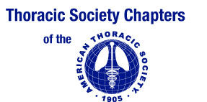

May 2016

Dear Colleague:

Last year, while rounding in our Neurointensive Care Unit, I evaluated a young African American patient with an intracerebral hemorrhage and thought: another case of obstructive sleep apnea syndrome (OSAS), another life forever changed because of an undiagnosed treatable risk factor for cardiovascular disease.

The story is usually the same: a middle-aged patient with refractory hypertension, and the classic overweight OSAS phenotype, presents with a cerebrovascular event. Others present with a history of multiple interventional cardiac procedures, without ever having been asked the classic questions about OSAS. Children with learning difficulties or behavioral problems are not screened. Yet, the disease affects millions and prevalence is higher in minority populations.

This prompted the Council of Chapter Representatives of the American Thoracic Society to create its first poster on Obstructive Sleep Apnea. A second poster on E-Cigarettes was produced in May 2016.

We appreciate your help distributing this poster, part of our Health Equality initiatives, to underserved communities to decrease the disabling and deadly effects of OSAS. Additional ATS patient information is available at: http://www.thoracic.org/patients .

We hope that this information is useful to your practice and appreciate your feedback at chapters@thoracic.org.

Sincerely,

Robin L. Gross, M.D.
Immediate Past Chair, Council of Chapter Representatives
American Thoracic Society

Associate Professor of Medicine
Georgetown University School of Medicine

